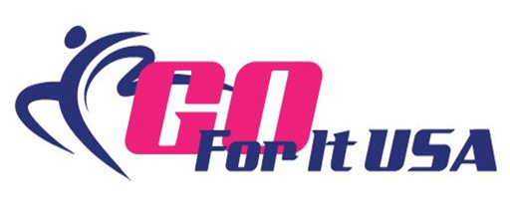

RELEASE AND WAIVER OF LIABILITY, ASSUMPTION OF RISK, AND INDEMNITY AGREEMENT (“AGREEMENT”)
In consideration of participating in any Activity at Go For It USA I represent that I understand the nature of this Activity and that I am qualified, in good health, and in proper physical condition to participate in such Activity. I acknowledge that if I believe event conditions are unsafe, I will immediately discontinue participation in this Activity. I fully understand that this Activity involves risks of serious bodily injury, including permanent disability, paralysis and death, which may be caused by my own actions, or inactions, those of others participating in the event, the conditions in which the event takes place, or the negligence of the “releasees” named below; and that there may be other risks either not known to me or not readily foreseeable at this time; and I fully accept and assume all such risks and all responsibility for losses, cost and damages I incur as a result of my participation in the Activity. I hereby release, discharge, and covenant not to sue Go For It USA, Vault Gymnastics LLC, its respective owner, administrators, directors, agents, officers, volunteers, and employees, other participants, any sponsors, advertisers, and, if applicable, owners and lessors of premises on which the activity takes place (each considered one of the ”releases” herein) from all liability claims, demands, losses, or damages, on my account or alleged to be caused in whole or in part by the negligence of the “releases” or otherwise, including negligent rescue operations and future agree that if, despite this release, waiver of liability, and assumption of risk I, or anyone on my behalf, makes a claim against any of the Releases, I will indemnify, save, and hold harmless each of the Releases from any loss, liability, damage, or cost, which any may incur as the result of such claim. I have read the RELEASE AND WAIVER OF LIABILITY, ASSUMPTION OF RISKS, AND INDEMNITY AGREEMENT, understand that I have given up substantial rights by signing it and have signed it freely and without any inducement or assurance of any nature and intend it to be a complete and unconditional release of all liability to the greatest extent allowed by law and agree that if any portion of this agreement is held to be invalid the balance, notwithstanding, shall continue in full force and effect.
Date:________________________
Printed name of participant ______________________________________________
Signature of participant_________________________________________________

